**163. Styling Active Recipe Items**

* Instructor: In the last lecture, we made our child route's links here work again.
* Now let's make clear which one is selected by marking it.
* We can mark the active link by adding, manually, the active class to it.
* If we do this, all are marked as active because, of course, it's added to every instance of this component because I hard-coded it in there.
* ***So that's the right class, but of course we should add it dynamically with good old routerLinkActive directive.***
* And here, I simply want to pass "active" as the class name because we just saw this is the CSS class we need to add.
* And with that, it's working as expected.

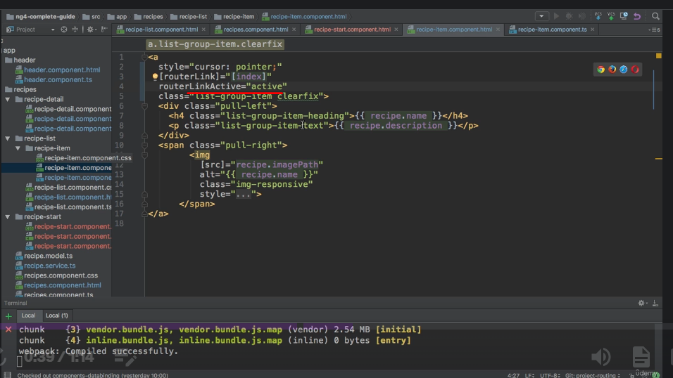

* And this is all we needed here.
* You also see that Recipes is still marked as active at the top because we still are at /recipes and then at a child route.
* But that doesn't matter for this to be marked as active because it's not set to exact matching.
* And actually, we want the behavior we have right now.
* So that all looks pretty good.
* Now we can move on to make sure that we can click this New Recipe button and this Edit Recipe button and actually do something once we do click them.